Name : Yedatkar Mohan Lobhaji Sub : Sem-II

Roll N0 : 271 Practical : 02

**Aim :** Create a webpage with HTML describing your department with following specification:

1. Change the background color of the page. At the bottom create a link to take user to the top of the page.
2. Insert an image and create a link such that clicking on image takes user to other page.
3. Also apply font styling like italics, underline and two other fonts to words you find appropriate. Also use header tags.

**Code:**

<!DOCTYPE html>

<html lang="en">

<head>

  <meta charset="UTF-8">

  <meta name="viewport" content="width=device-width, initial-scale=1.0">

  <title>Computer Science & Engineering Department</title>

  <style>

    body {

      background-color: #e6f7ff; /* Light blue background */

      font-family: 'Arial', sans-serif;

      color: #333;

      padding: 20px;

      line-height: 1.6;

    }

    h1, h2, h3 {

      color: #00509e;

    }

    .italic {

      font-style: italic;

    }

    .underline {

      text-decoration: underline;

    }

    .highlight {

      font-family: 'Georgia', serif;

      color: #d35400;

    }

    .image-link img {

      width: 100%;

      max-width: 600px;

      border-radius: 10px;

      transition: transform 0.3s ease;

    }

    .image-link img:hover {

      transform: scale(1.05);

    }

    .top-link {

      text-align: center;

      margin-top: 20px;

    }

    .top-link a {

      font-weight: bold;

      text-decoration: none;

      color: #0077cc;

    }

    .top-link a:hover {

      text-decoration: underline;

    }

    table {

      width: 100%;

      border-collapse: collapse;

      margin-top: 20px;

    }

    th, td {

      padding: 10px;

      border: 1px solid #ddd;

    }

    th {

      background-color: #00509e;

      color: white;

    }

    td {

      background-color: #f0f8ff;

    }

  </style>

</head>

<body>

  <!-- Top Anchor -->

  <a id="top"></a>

  <h1>Department of Computer Science & Engineering</h1>

  <h2>Welcome to Our Department</h2>

  <p class="italic">

    Established in <span class="underline">1984</span>, our department has consistently maintained steady growth, fostering a vibrant and forward-looking academic environment.

  </p>

  <p>

    We offer high-quality undergraduate and postgraduate engineering courses, providing excellent infrastructure and facilities for state-of-the-art technical education and research.

  </p>

  <h3>Department Highlights</h3>

  <ul>

    <li>Research centers affiliated with Swami Ramanand Teerth Marathwada University, Nanded & Dr. Babasaheb Ambedkar Technological University, Lonere for Ph.D. in CSE.</li>

    <li>Received research grants totaling Rs. 59.99 Lakhs from agencies such as BARC Mumbai, AICTE Delhi, and AMUPMDC Mumbai.</li>

  </ul>

  <h3>Department Details</h3>

  <table>

    <tr>

      <th>Detail</th>

      <th>Information</th>

    </tr>

    <tr>

      <td>Location</td>

      <td>South Wing, Underground</td>

    </tr>

    <tr>

      <td>Year of Establishment</td>

      <td>1984</td>

    </tr>

    <tr>

      <td>Head of Department</td>

      <td>Dr. Mrs. A. M. Rajurkar</td>

    </tr>

    <tr>

      <td>Contact No</td>

      <td>02462 224756</td>

    </tr>

    <tr>

      <td>Email ID</td>

      <td>rajurkar_am@mgmcen.ac.in</td>

    </tr>

    <tr>

      <td>Total No of Classrooms</td>

      <td>5</td>

    </tr>

    <tr>

      <td>Total No of Laboratories</td>

      <td>10</td>

    </tr>

    <tr>

      <td>Number of Professors</td>

      <td>3</td>

    </tr>

    <tr>

      <td>Number of Assistant Professors</td>

      <td>17</td>

    </tr>

    <tr>

      <td>Total Teaching Faculty</td>

      <td>20</td>

    </tr>

    <tr>

      <td>Supporting Teaching Staff</td>

      <td>10</td>

    </tr>

  </table>

  <h3>Vision</h3>

  <p>

    To be one of the leading Departments for Computer Science & Engineering education, developing proficient Engineers with global acceptance in the service of mankind.

  </p>

  <h3>Mission</h3>

  <p>

    Providing technical skills with strong fundamentals of Computer Science discipline with an emphasis on software development.

Inculcating analytical, programming and multidisciplinary skills to enhance employability.

Fostering problem-solving, team-building, and lifelong learning skills with societal, environmental and ethical sense.

Developing researchers and entrepreneurs to solve real-life problems through industry interactions and collaborations.

  </p>

  <div class="top-link">

    <p><a href="#top">Back to Top</a></p>

  </div>

</body>

</html>

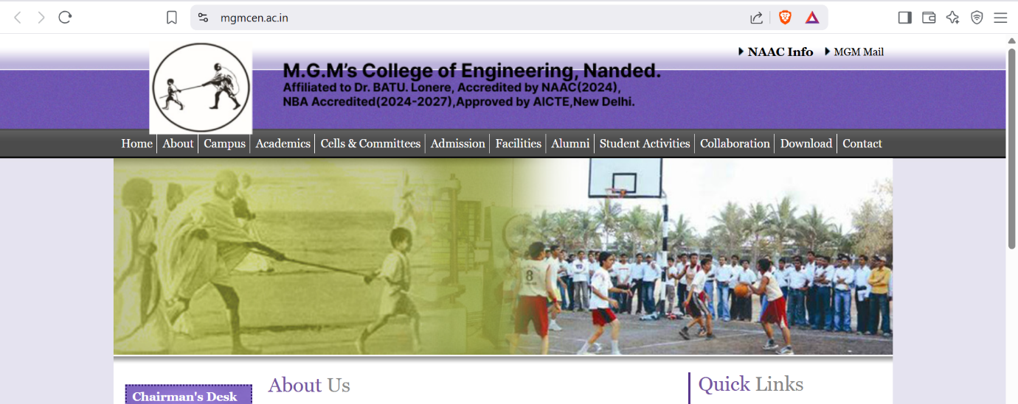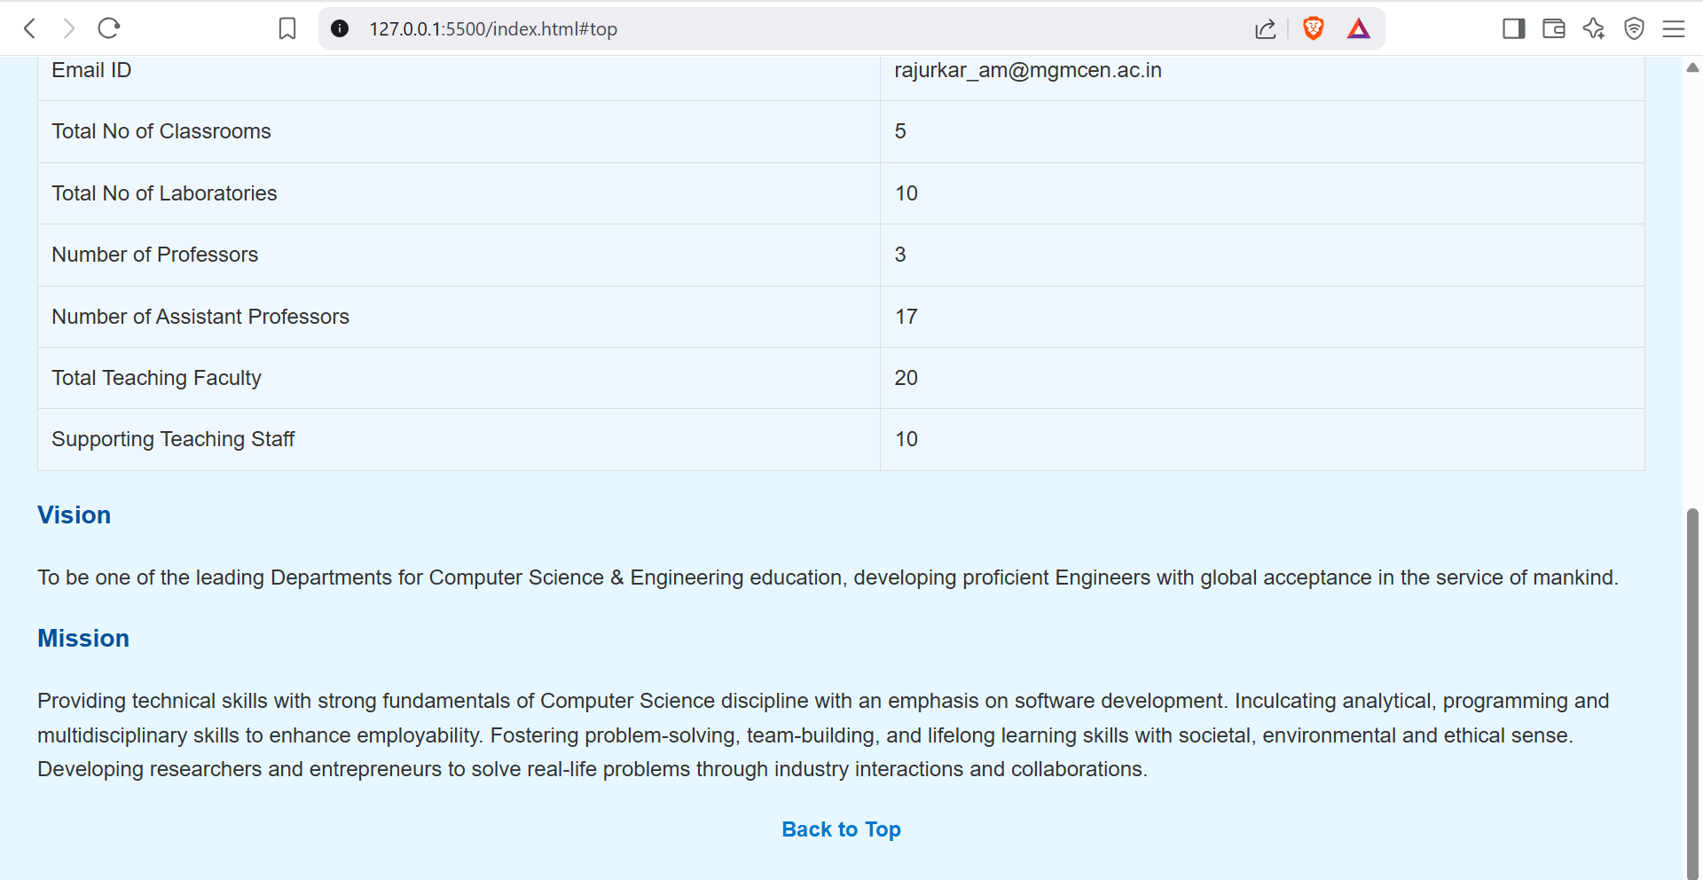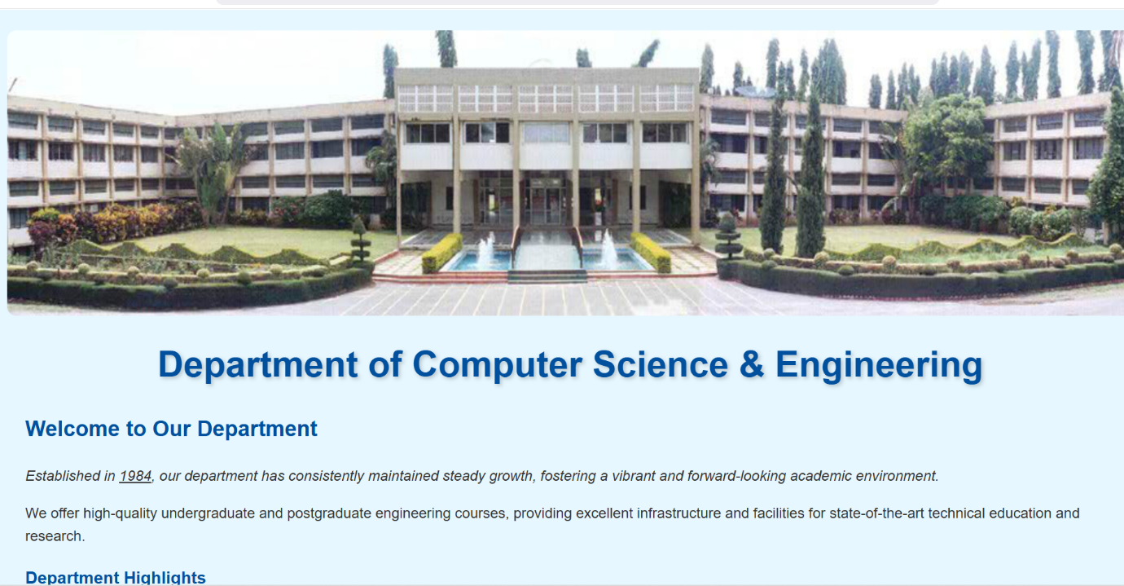**Output:**